Appendix A
Review of Treasury Management Activity 2016/17

Introduction

The County Council’s Treasury Management activity is underpinned by CIPFA’s Code of Practice on Treasury Management (“the Code”), which requires authorities to produce Prudential Indicators and a Treasury Management Strategy Statement on the likely financing and investment activity annually. The Code also recommends that members approve a treasury management report after the end of each financial year.

Economic Summary 2016/17

Treasury Management activity is influenced by the actual and forecast economic position. The economic situation in the year was largely dominated by the uncertainty about the short and medium term implications of the decision in June 2016 to leave the European Union. In response to the risk of reduced economic growth the Bank of England Monetary Policy Committee initiated substantial monetary policy easing at its August meeting. This included a cut in Bank Rate to 0.25%, further gilt and corporate bond purchases (QE) and cheap funding for banks (Term Funding Scheme) to maintain the supply of credit to the economy.

The year has seen steady economic growth although the final quarter is at a lower rate with the quarterly rates being:

Quarter ended : | GDP growth (%)
June 2016 | 0.6
September 2016 | 0.5
December 2016 | 0.7
March 2017 | 0.2

Inflation remained low in the first half of 2016 but there has been signs of this increasing towards the end of the year with inflation as measured by RPIH being at 2.3% at March 2017. However, since the referendum vote the value of sterling has fallen and this is a significant factor behind the increase in inflation. The unemployment rate dropped to 4.7% in February, its lowest level in 11 years.

The year has seen significant volatility in the financial markets as a result of both the UK vote to leave the European Union and Donald Trump being elected as President of the USA. As a consequence of the uncertainty Gilt yields fell, Fitch and Standard & Poor’s downgraded the UK’s sovereign rating to AA and the value of sterling fell. The impact of the negotiations to leave the European Union will be a source of on-going uncertainty.

Interest Rate Environment

Short term interest rates continue to be at historically very low levels. As referred to above in response to a potential reduction in economic growth the Bank of England reduced the base rate from 0.5% to 0.25% in August 2016, a level it remained at throughout the rest of the year. The expectation during the year was that interest rates would remain low for the rest of the financial year and beyond. This is still the case with the Council's Treasury Management advisers, Arlingclose, not forecasting an increase to June 2020.

Treasury Management Strategy 2016/17

The Treasury Management activity is undertaken in accordance with the Treasury Management Strategy. Full Council approved the 2016/17 Treasury Management Strategy at its meeting on 11 February 2016. The Council’s stated investment priorities were:
(a) Security of capital and
(b) Liquidity of investments

The Council policy, which has been in place for a number of years, is a deliberate "low credit risk" investment policy, using bonds issued by governments, government agencies, government guaranteed bodies, supranational bodies and covered or collateralized corporate bonds. The County Council's policy is not to invest in banks, other than call accounts and therefore it is substantially insulated from the effects of an individual or systemic banking "credit event". This control of credit risk was a key driver in the investment activity in 2016/17. However, with the predicted reduction in reserves moves were made to reduce long term investment holdings to reduce market risk.

The Council will also aim to achieve the optimum return on its investments commensurate with proper levels of security and liquidity. The risk appetite of the Council is low in order to give priority to security of its investments.

The Council’s stated borrowing strategy was to take advantage of historically low short term interest rates by borrowing short term in the money markets rather than financing capital expenditure through long term Public Works Loan Board (PWLB) loans. Since this strategy was first implemented in 2010/11 the Council has taken advantage of low interest rates to reduce the cost of financing current and former years' capital programmes. This strategy continued to be implemented in 2016/17 and will continue to be the most cost effective financing method until there is a significant increase in interest rates.

The Director of Financial Resources can report that all Treasury Management activity undertaken during the financial year complied with the CIPFA Code of Practice and the relevant legislative provisions.

Treasury Management Activities in 2016/17

In summary the holdings were:

 | 31/3/17 | 31/3/16
 | £m | £m
Long term borrowing | 582.4 | 581.4
Short term borrowing | 457.3 | 392.2
Total Borrowing | 1,039.7 | 973.6
Long term investments | 399.9 | 552.8
Short term investments | 174.6 | 24.7
Total Investments | 574.5 | 577.5

Borrowing Activity 2016/17

During the year borrowing was undertaken to finance new capital investment, to replace maturing debt and to cover short term cash-flow variations. With the low interest rates anticipated to continue the Council maintained its policy of taking short term market borrowing and this is reflected in the activity during the year and the structure of the debt at 31 March 2017. This is illustrated in the table and graph as follows.

Analysis of Borrowing Outstanding

 | Debt 31/03/2016 |  | Borrowing | Repayments | Debt 31/03/2017
 | £m | % | £m | £m | £m | %
Fixed Rate Funding
Public Works Loan Board | 213.1 | 21.9 | - | - | 213.1 | 20.5
LOBO* | 50.0 | 5.1 | - | - | 50.0 | 4.8
Market Borrowing | 522.4 | 53.7 | 545.5 | -477.9 | 590.0 | 56.7
Total Fixed Rate Funding | 785.5 |  | 545.5 | -477.9 | 853.1
Variable Rate Funding
Public Works Loan Board | 125.7 | 12.9 | - | - | 125.7 | 12.1
Shared Investment Scheme | 62.4 | 6.4 | 512.9 | -514.5 | 60.8 | 5.9
Total Variable Rate Funding | 188.1 |  | 512.9 | -514.5 | 186.5
Total Loan Debt | 973.6 | 100.0 | 1,058.4 | -992.4 | 1,039.6 | 100.0

*Lender option borrower option

With short-term interest rates being lower than long-term rates, it was more cost effective in the short-term to borrow short-term loans from the market, mainly from other local authorities. Whilst such a strategy is most likely to be beneficial over the next year as official interest rates remain low, it is unlikely to be sustained in the medium-term. The Director of Financial Resources will, in conjunction with Arlingclose, continue to closely monitor interest rate forecasts in order to establish when long term interest rates might be expected to rise and adjust the strategy accordingly.

Overall the average rate of interest paid in 2016/17 on the debt administered by the County Council was 2.12% per annum compared with an average rate of 2.03% in 2015/16, 2.07% in 2014/15 and 2.48% in 2013/14.

Other Debt

The County Council did not enter into any new other long term liability arrangements in the year. The outstanding PFI liability at 31 March 2017 was £162.4m.

Investment Activity

In undertaking investments, consideration is given to the risk and liquidity within the portfolio. The maturity of the investment, the asset type, the country invested in and the credit rating are also considered.

Total investments analysed by asset type (March 2017)

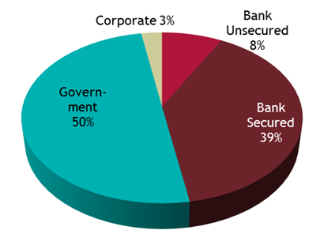

The total amount of investments (excluding fair value adjustment) held by the County Council at 31 March 2017 was £574.53m. This is £2.99m lower than at 31 March 2016. The table below shows the holding of investments:

Investments by Maturity

 | Position as at 31/3/16 | 2016/17 Movement | Position as at 31/3/17
Maturity Range | £m | £m | £m
Call, Money Market Funds & Under 1 year | 20.71 | 126.99 | 147.70
Bank Deposit 1-2 years | - | 36.50 | 36.50
Bank & Local Authority Deposits 2-3 years | 36.50 | -36.50 | -
Bank Deposit 5 years + | 10.00 | - | 10.00
Local Authority Bonds | 36.45 | -0.60 | 35.85
UK Government and Supranational Bonds | 473.86 | -129.38 | 344.48
Total | 577.52 | -2.99 | 574.53

The graph below shows the maturity dates of assets against their exposure to bail-in risk in the event of a bank default (i.e. the risk that the investment may be lost or the principal repaid significantly reduced). The Council has been moving away from unsecured bank deposits as an asset class and apart from on-call balances they no longer form an allowable investment class under the 2016/17 Treasury Management Policy.

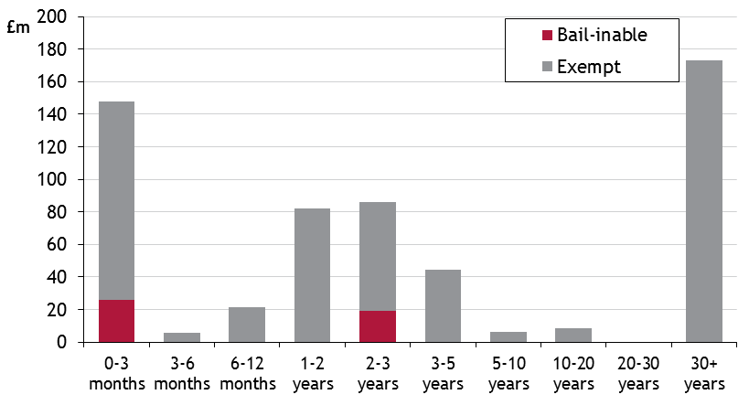

Investments are considered very secure, with over 29% rated AAA or AA+, with the others rated at A or above. The average credit score of 2.46/AA+ is well within the policy limit of 5/A+.

Security of capital remained the County Council’s main investment objective. This was maintained by following the County Council’s Counterparty Policy, as set out in its Treasury Management Strategy Statement for 2016/17. This defined “high credit quality” organisations as those having a minimum long-term credit rating of A+. In practice the average credit rating in 2016/17 was higher at AA.

Investments with banks were held in call accounts only. Any longer term deposits have been restricted to other local authorities. As at March 2017:

Liquidity Management

In keeping with the DCLG’s Guidance on Investments, the Council maintained a minimum level of primary liquidity through the use of 'call accounts'. The Council also has bond portfolios which are available for sale, at current market prices, if needed as “secondary” liquidity.

The Council uses purpose-built cash flow forecasting spreadsheets to determine the maximum period for which funds may prudently be committed.

Yield
The rates of return on the Council's short-dated money market investments reflect prevailing market conditions and the Council's objective of optimising returns commensurate with the principles of security and liquidity.

Overall the investment portfolios returned an average rate of 4.66% in 2016/17 which can be attributed to the categories as follows:

Maturity Range | Investment  £m | Average Rate
Call, MMF & Under 1 year | 147.70 | 0.54%
Bank & Local Authority Deposits 1-2 years | 36.50 | 1.44%
Bank & Local Authority Deposits 2-3 years | 0.00 | 0.00%
Bank & Local Authority Deposits 3-5 years | 0.00 | 0.00%
Bank & Local Authority Deposits 5 Years + | 10.00 | 2.95%
Local Authority Bonds | 35.85 | 3.67%
UK Government & Other Bonds | 344.48 | 5.71%
 | 574.53 | 4.66%

Impact of the Treasury Management Strategy on the Council's revenue budget

The table below shows a net underspend of £23.425m against the budget for financing charges. As outlined, the markets saw some volatility in the year principally as a result of the referendum to leave the EU. The increase in the price of Gilts enabled some core Gilt holdings to be sold resulting in the overall net gain. This level of volatility was unexpected and therefore no provision for surplus on sale of assets was included in the budget.

Financing Charges 2016/17 – End of Year Position

 | Budget  16/17 | Year End  Position | Variance
 | £m | £m | £m
MRP | 19.970 | 20.046 | 0.076
Interest Paid | 24.280 | 22.340 | -1.940
Interest Received/surplus on sale | -11.670 | -33.231 | -21.561
Total | 32.580 | 9.155 | -23.425

Treasury Management and Prudential Indicators 2016/17

The Local Government Act 2003 and supporting regulations require the County Council to have regard to the Prudential Code and to set prudential indicators to ensure the Council's capital investment plans are affordable, prudent and sustainable.

A comparison of the actual position at 31 March 2017 compared to the revised 2016/17 indicators set in the Treasury Management Strategy for 2016/17 is set out as follows:

Prudential Indicators

1. Adoption of CIPFA Treasury Management Code of Practice | Adopted
 | £m | £m
 | 2016/17 | 2016/17
 | Indicator | Actual
2. Authorised limit for external debt
The Authorised Limit is a prudent estimate of debt which reflects the Authority's capital expenditure plans and allows sufficient headroom for unusual cash movements.
Borrowing | 1,100.0 | 1,039.7
Other long term liabilities (PFI schemes) | 200.0 | 162.4
TOTAL | 1,300.0 | 1,202.1
3. Operational boundary for external debt
The Operational Boundary is a prudent estimate of debt but has no provision for unusual cash movements. It represents the estimated maximum external debt arising as a consequence of the County Council's current plans.
Borrowing | 1,050.0 | 1,039.7
Other long term liabilities (PFI schemes) | 170.0 | 162.4
TOTAL | 1,220.0 | 1,202.1
4. Capital Financing Requirement to Gross Debt
The Capital Financing requirement is the underlying need to borrow for capital purposes. This is the cumulative effect of past borrowing decisions and future plans. This is not the same as the actual borrowing on any one day, as day to day borrowing requirements incorporate the effect of cash flow movements relating to both capital and revenue expenditure and income.

Capital Financing Requirement | 1,006.0 | 990.1
Gross debt | 1,010.0 | 1,033.6
Debt to Capital Financing Requirements | 1.00 | 1.04

Gross borrowing appears higher than the capital financing requirement because the shared investment scheme is accounted for as borrowing, but it does not form part of the capital financing requirement calculation. Adjustments are also required for Premiums, long term debtor and transferred debt. The adjusted gross debt is slightly above the CFR which represents borrowing in advance for capital and is within the Code.

 | 2016/17 | 2016/17
 | Indicator | Actual
5. Council Tax Indicators
Ratio of financing costs to the net revenue stream | 4.64% | 1.28%

The County Council confirms that it has complied with its Prudential Indicators for 2016/17, which were approved as part of the County Council’s Treasury Management Strategy.

Treasury Management Indicators | Upper Limit | Actual
 | £m | £m
1. Interest Rate exposure
The limit measures the County Council's exposure to the risk of interest rate movements. The one year impact indicator calculates the theoretical impact on the revenue account of an immediate 1% rise in all interest rates over the course of one financial year.
Net Interest Payable – Fixed Rate | 50.4 | 10.4
Net Interest Payable – Variable Rate | 5.0 | 2.5
1 year impact of a 1% rise | 10.0 | 1.3
2. Maturity structure of debt
The limit on the maturity structure of debt helps control refinancing risk.
Under 12 months | 75 | 44
12 months and within 2 years | 75 | 15
2 years and within 5 years | 75 | 17
5 years and within 10 years | 75 | 5
10 years and above | 100 | 19
3. Investments over 364 days
The limit on the level of long term investments helps to control liquidity, although the majority of these investments are held in available for sale securities.
Total invested over 364 days | 450.0 | 399.9
4. Minimum Average Credit Rating | Benchmark | Actual
To control credit risk the County Council requires a very high credit rating from its treasury counterparties.
Average counterparty credit rating | A+ | AA+

